**CUSTOM DOCKER IMAGE**

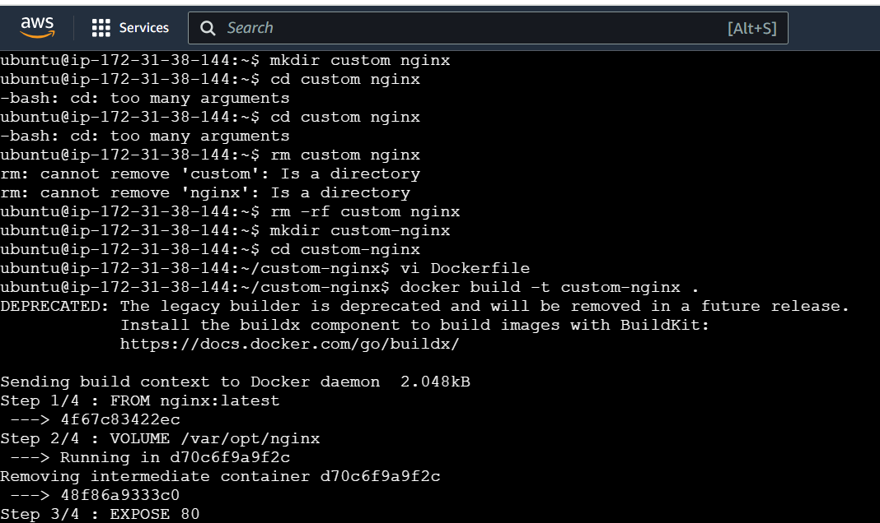

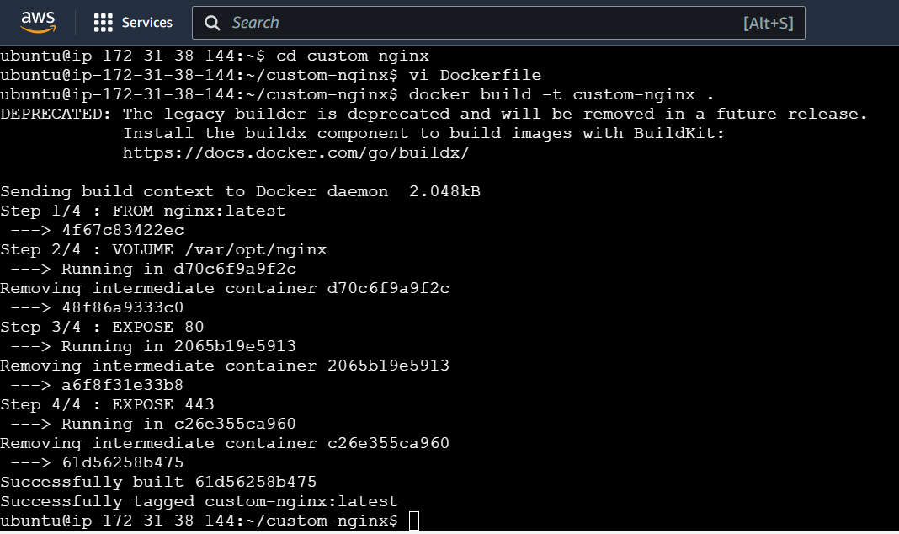

**DOCKERFILE**

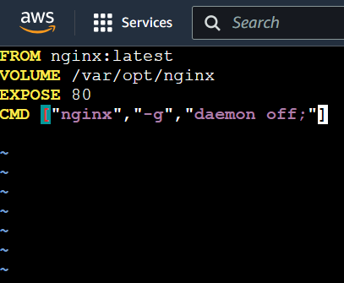

**RENAMING**



**DOCKERHUB REPOSITORY**

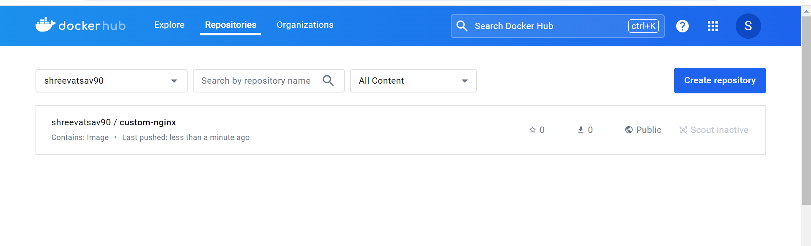

**COMMAND**

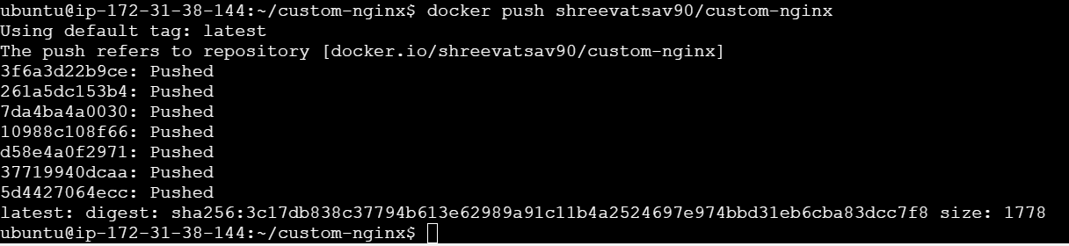

**DOCKER COMPOSE**



**DOCKER COMPOSE FILE**

